Story 04 Add a Book

## Description

As a user

I want to add a book

So that it will be stored in the database

## Wireframe

Happy case:

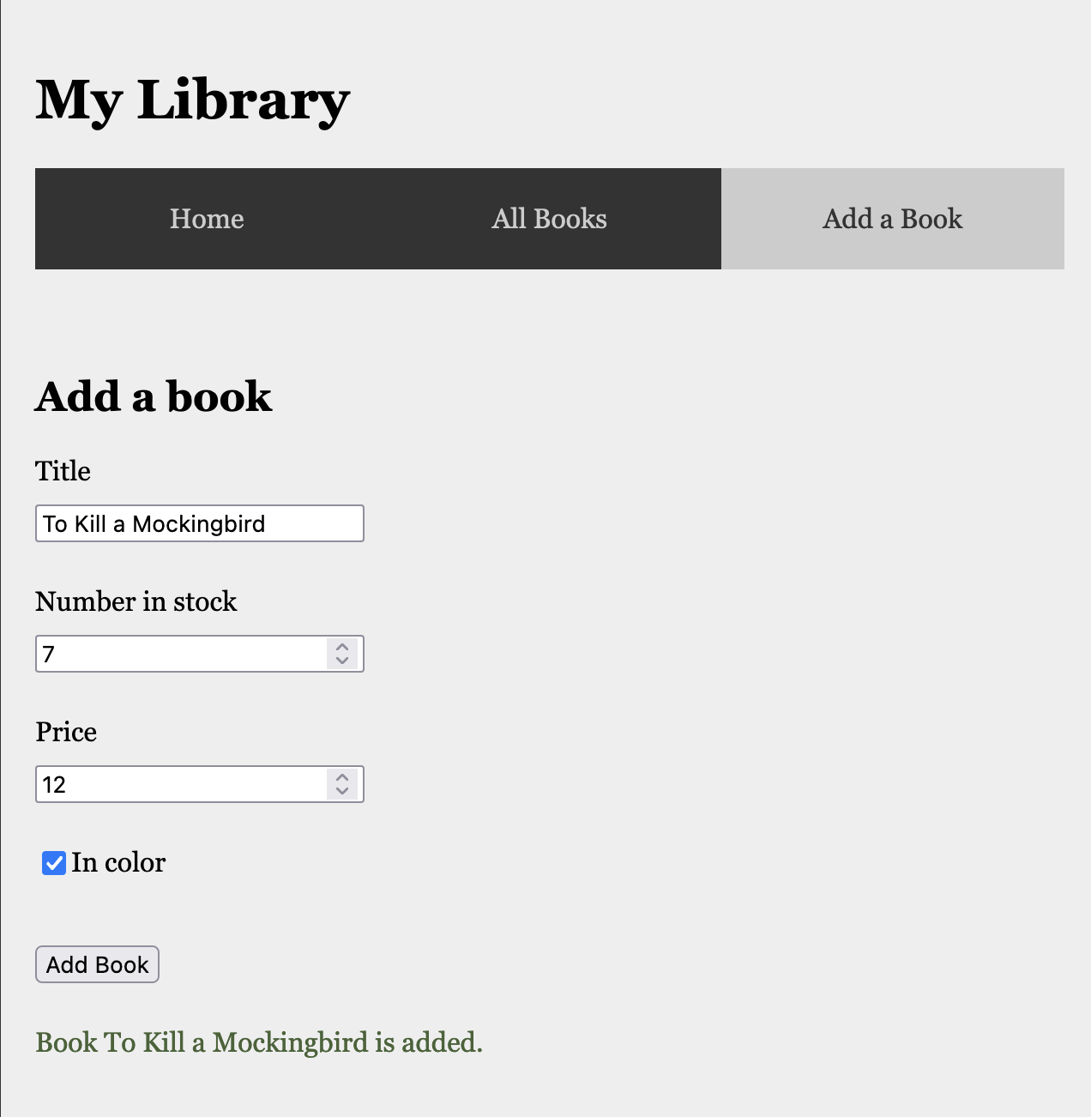

Unhappy case:

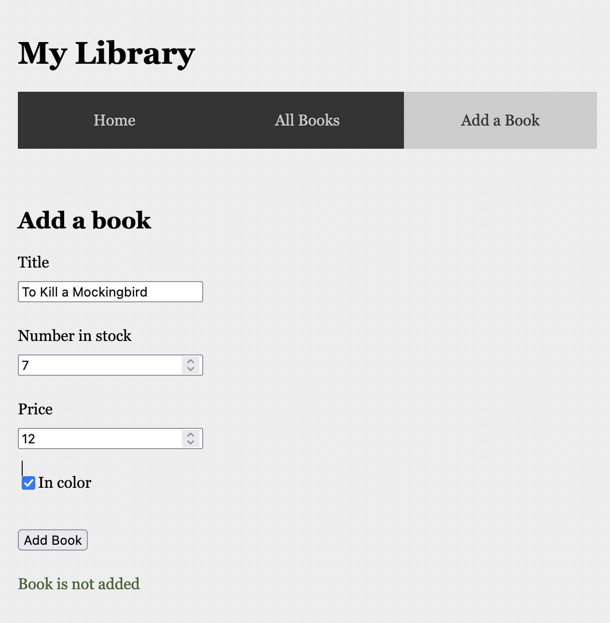

## Acceptance Criteria

* A book with given title can only be added once
* When a user fills in all fields and there is no book in the collection with the given title
  + A confirmation text with book title is shown below the form
  + the book is added to the database
  + the book is rendered on the overview page
* When a user tries to add a book with title that already is in the collection
  + the text “Book is not added” is shown below
  + the book is not added to the database

## API

|  |  |
| --- | --- |
| **Add a Book** | |
| **Request** | POST |
| **URL** | <http://localhost:8080/api/book/add> |
| **Input** | JSON object with fields “title” (String), “numberInStock” (int), “price” (double), “inColor” (Boolean) |
| **Output: Happy Case** | JSON book object with fields “id” (int), “title” (String), “numberInStock” (int), “price” (double), “inColor” (Boolean), “priceInDollar” (double) |
| **Output: Unhappy Case** | / (no validation at this moment) |
| **Acceptance Criteria** | The given book is added to the h2 database when there is no book with the given title already in the collection. |

## Technical Requirements

* The book is stored in a h2 database